**Elizabeth Wathuti, young climate activist, Kenya**

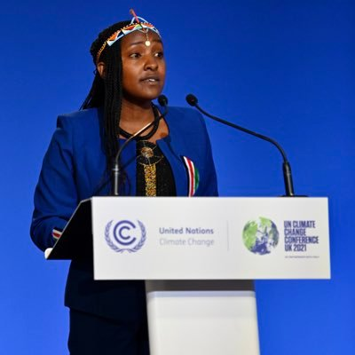

Elizabeth is a Green Climate Fund Youth Champion, and the founder of the Green Generation Initiative. She calls for solidarity and compassion in our efforts to address the world’s growing climate and ecological crises.

Elizabeth founded the Green Generation Initiative in 2016 - a youth-led initiative aimed at addressing environmental issues through education, tree growing for impact, advocacy, and activism. She was determined to empower communities, particularly children and young people, to find solutions to the climate and ecological crisis.

At COP26 in Glasgow, Elizabeth asked global leaders to open their hearts to those suffering the devastating impacts of climate change. As she stood in front of thousands of participants, many with the power and resources to act, she spoke of the harsh realities facing over 2 million Kenyans who do not have enough to eat due to deforestation and climate change-induced disasters like droughts and floods.

“We need more climate activists on board, we need more people who care and are concerned about the planet to join this movement and makes sure that we are holding everyone accountable, because this is also about system change. This is also about individual responsibility.”

**“Most of the things that are happening in the world right now are because we have chosen to put profits above the people and our planet. But if we can get everybody around the world to love nature, to appreciate nature, and to make sure that we are doing this from deep within our hearts and deep within ourselves, then we can change so much in the world within a short period of time.”**